Ex:No: 13

Date:

**Simple programming using CASE and LOOP**

**Aim:**

To learn how to use various MySQL loop statements including case and loop to run a block of code repeatedly based on a condition.

**Procedure:**

In MySQL, the CASE statement has the functionality of an IF-THEN-ELSE statement and has 2 syntaxes that we will explore.

**CASE Syntax**

CASE case_value

WHEN when_value THEN statement_list

[WHEN when_value THEN statement_list] ...

[ELSE statement_list]

END CASE

**Procedure:**

LOOP Syntax

[begin_label:] LOOP

statement_list

END LOOP [end_label]

LOOP implements a simple loop construct, enabling repeated execution of the statement list, which consists of one or more statements, each terminated by a semicolon (;) statement delimiter. The statements within the loop are repeated until the loop is terminated. Usually, this is accomplished with a LEAVE statement. Within a stored function, RETURN can also be used, which exits the function entirely.

**Program 1:**

Write a function that uses CASE statement where if monthly_value is equal to or less than 4000, then income_level will be set to 'Low Income'. If monthly_value is equal to or less than 5000, then income_level will be set to 'Avg Income'. Otherwise, income_level will be set to 'High Income'.

**Program 2:**

Write a function that will use ITERATE statement which would cause the loop to repeat while income is less than 4000. Once income is greater than or equal to 4000, would terminate the LOOP.

**Program -1**

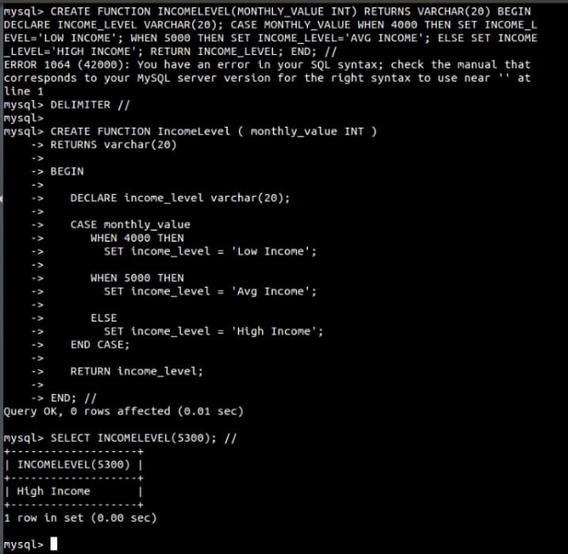

**Program -2**

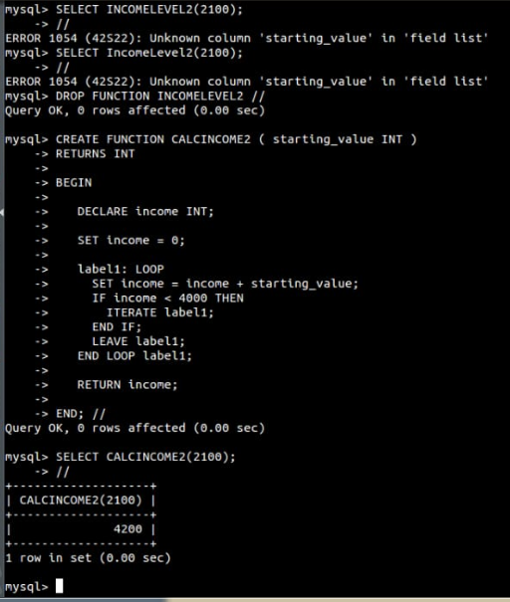

**RESULT:** Thus the Simple programming exercise using CASE and LOOP executed successfully.